**Agenda**

Structures

Permutations

C++  
- intro  
- vectors  
- functions

Assignment 2 Info

GDB

FCS

Lab: Lab_struct

**Structures**

Definition: A structure is a collection of one or more variables grouped together under a single name for convenient handling. Often called a record in other languages.

Ex. Student Record

Name ____________ (String)

Student # ___________ (int)

Email ___________ (string)

Major ___________ (int/string)

*note Major can have different variations of a string that means the same thing  
ex. Faculty of Law, faculty of law, law faculty etc…  
normalize it through another table that represents an “Official String” of the faculty (therefore represented by an int or one abbreviation string)

Ex. Chemical Element

Name ________(String)

Symbol ________(String)

Atom Number _________(int)

Atom Weight ___________(double)

Declaring a Structure & Initializing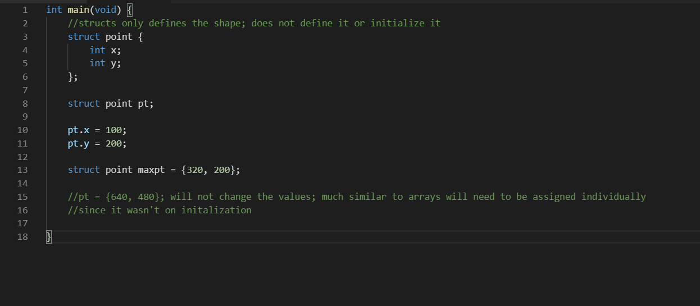

Legal Operations on Structures

* Copy it
* Assign to it as a unit
* Take address of (using &)
* Access its members

Exercise: Create a Driver’s License

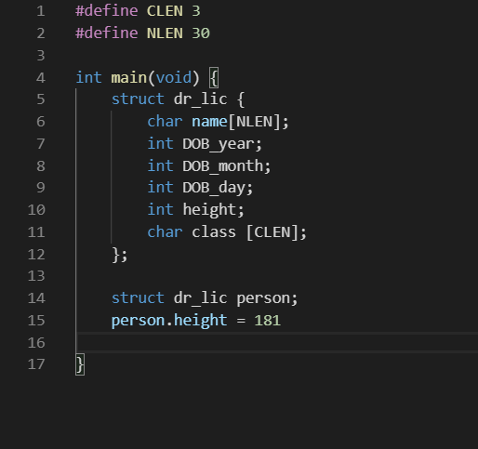

**Permutations**

|  |  |  |
| --- | --- | --- |
|  | Arrays | Structures |
| Arrays | Multi-Dimensional Arrays | Array of Structures |
| Structures | Structure containing Arrays | Structure of Structures |

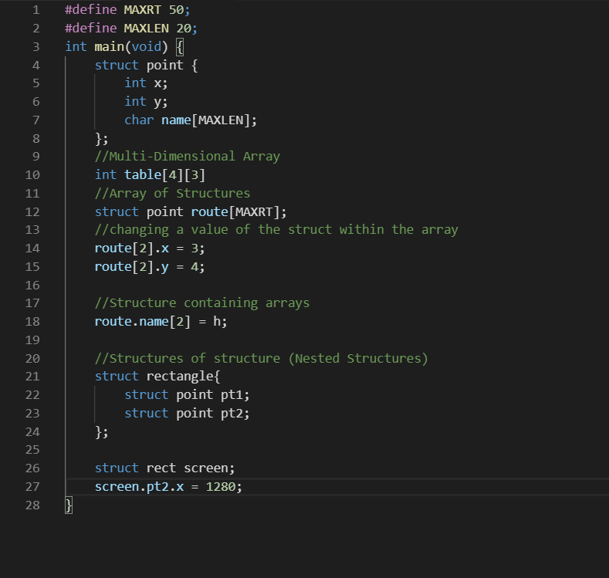

Examples: Ihypress chapter 10

Typedef

A method of creating a user defined type

Scalar

Type def int numtype; (int is a base type) – num is now a type and we can declare a variable with it

numtype count;

Combining Typedef with struct

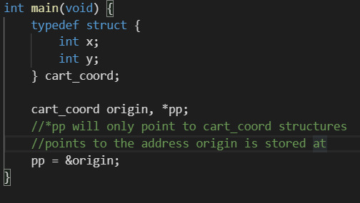

Pointers and Structures

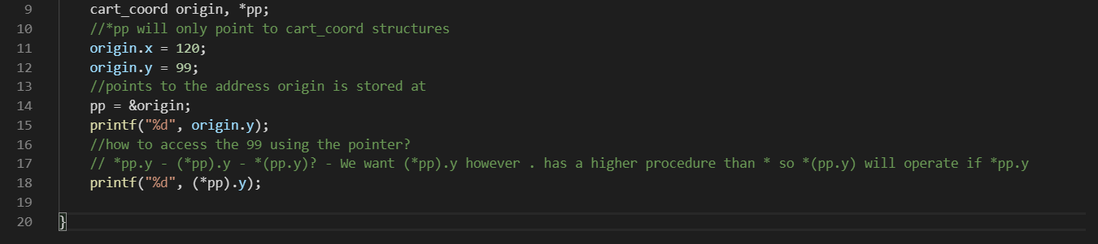

Because pointers & structures are so common there is a shorthand notation to dereference a pointer to a structure

Pointer -> member_field

e.g pp -> y

https://i.gyazo.com/3728c85d28771c75676605a19f36770e.png

This notation is more common

Linked Lists (Will not be on exam)

Implementing a Linked List into C would use structs

**C++**

**Intro**

* Created by Bjarne Stroustrup
* Object-oriented version of C
* C++ mostly pertains C (only a little bit of C was not carried over to C++)

Template/Skeleton for C++ Program

#include <iostream> (similar to the stdio.h)

Using namespace std;

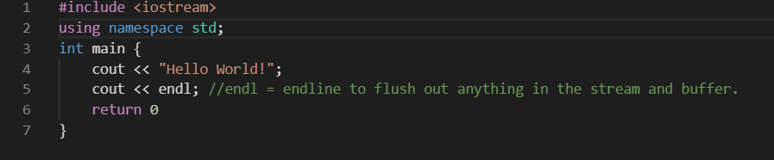

* How to compile the file?
* g++ hello.cpp
* ./a.out

**Vectors**

Similar to arrays but much more dynamic (Zybooks section 13)

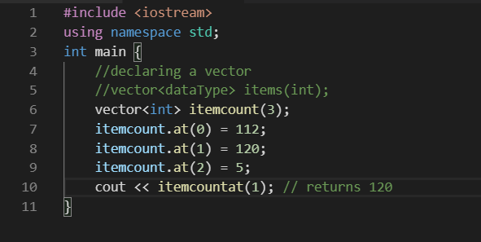

Functions of Vectors

* Using the size() function to determine the size of the vector
  + Itemcount.size();
* It is possible to change a vector size while the program executes
  + Use the resize() function
* Pushback(int) function
  + Will increase the vector size while appending the value given to the end
* Back() function
  + Checks the last element of the vector
* Popback() function
  + Opposite of the pushback function
  + Will remove the last element of the vector while decreasing the size
* Vectors are able to be compared or copy
* Resizing will chop the end of the vector or add to the end of the vector

Refer Zybooks 13.5.1

Assignment 2 Info

Genetic Code has four possible letters AGCT

Can be a combination of any of the three letters

Ignore any space or other characters that are within the text

Is not case sensitive(a and A represent the same)

Print * for the code TAA that appears